OPERATING SYSTEMS AND SYSTEMS PROGRAMMING

Sec:- 2

Name:- Sai Sowseelya Vedula
RollNo:- 2520030260

Practical 3 & 4

Develop a C program using fork() that creates a parent and child process. Display the Process ID (PID), Parent Process ID (PPID), and process states at different stages of execution.
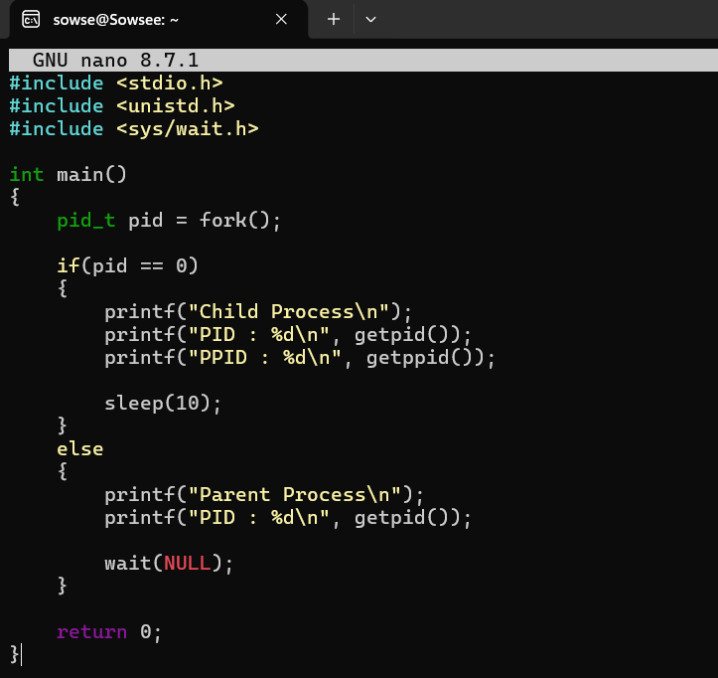
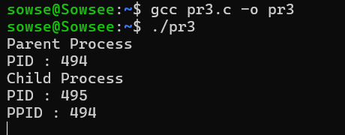

Write a C program where a parent process creates multiple child processes and synchronizes their completion using wait() and waitpid(). Compare the behavior of both functions.
